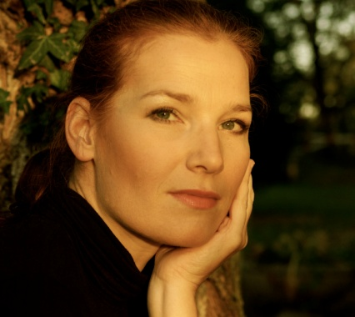
BEA ROBEIN

37 Rue du Lac 69003 Lyon France
+33 669 657733 bearobein@hotmail.com
www.bea-robein.com

Bea Robein recently debuted as Brünnhilde in Götterdämmerung to great acclaim at the Festspiele Erl 2018: before Brünnhilde she made her first forays into the soprano repertoire with Leonore in Fidelio(Theater Trier) and Sylva Varescu in Die Csardasfürstin(Aalto Theater Essen).
After starting her career in The Cunning little Vixen(Janáček) at Volksoper Wien Bea sang numerous mezzo parts: Dorabella/ Donna Elvira/ Cherubino/ Idamante/ Despina(Mozart), Brangäne/ Wellgunde(Wagner), Carmen(Bizet), Hänsel (Humperdinck), Orlofsky(Strauss), Mrs.Quickly and Fenena(Verdi). Her interest in contemporary music led her to collaborations with composers such as Christian Jost including Die arabische Nacht (Aalto-Musiktheater Essen) and Max Nagls Der siebte Himmel for Bregenzer Festspiele. With operas like Philip Glass’ Satyagraha (Oper Bonn/Festspielhaus St. Pölten), Ullmanns Der Kaiser von Atlantis/ Trommler, Schnittkes Die Historia von D. Johann Fausten/Mephostophila(Neue Oper Wien) or Bergs Lulu/Gräfin Geschwitz she was able to intensify her enthusiasm for 20th century music.
She was a guest in opera houses like Staatstheater Karlsruhe, Volksoper Wien, Theater Bonn, Landestheater Linz, Aalto Theater Essen, Bühne Baden, Stadttheater Klagenfurt and to renowned festivals such as Bregenzer Festspiele, Styriarte, Festspiele Erl, where she collaborated with stage directors like Stefan Herheim, Tilman Knabe, Karoline Gruber, Dietrich Hilsdorf, Anselm Weber, Ludger Engels, Immo Karaman, Silviu Pukarete, Ronzoni/Wahl and Michael Sturminger.
On the concert platform Bea partners regularly with renowned orchestras: Sheherazade with Rotterdam Philharmonic Orchestra under Gianandrea Noseda, Wesendonck-Lieder with Limburg Symphony Orchestra under Mark Shanahan, Das Lied von der Erde with Orchestre Victor Hugo Franche Comté and Jean Francois Verdier, Beethovens 9th Symphony with Orchestre National de Lyon and Leonard Slatkin. Furthermore she collaborated with the Mozarteum Orchester, the Niederösterreichischen Tonkünstler Orchester, ensembles including the Academia Montis Regalis, the Amber Trio Jerusalem, die reihe, and Quatuor Psophos. Bea has sung under the baton of conductors such as Stefan Soltesz, Jan Latham König, Marc Soustrot, Michael Güttler, Steven Sloane, Alessandro de Marchi, Ed Spanjaard, Alexander Soddy, Pietro Rizzo, Douglas Boyd, Alexander Liebreich, Constantin Carydis, Sebastien Rouland, Alexander Drcar, Peter Keuschnig, Rudolf Bibl and Michael Hofstätter.
Future engagements include Fatinitza( Suppé) a new production for Bühne Baden and her first Tosca in summer 2020.

